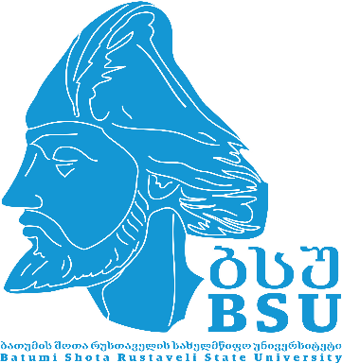

**Batumi Shota Rustaveli State University**

**VI International Staff Week**

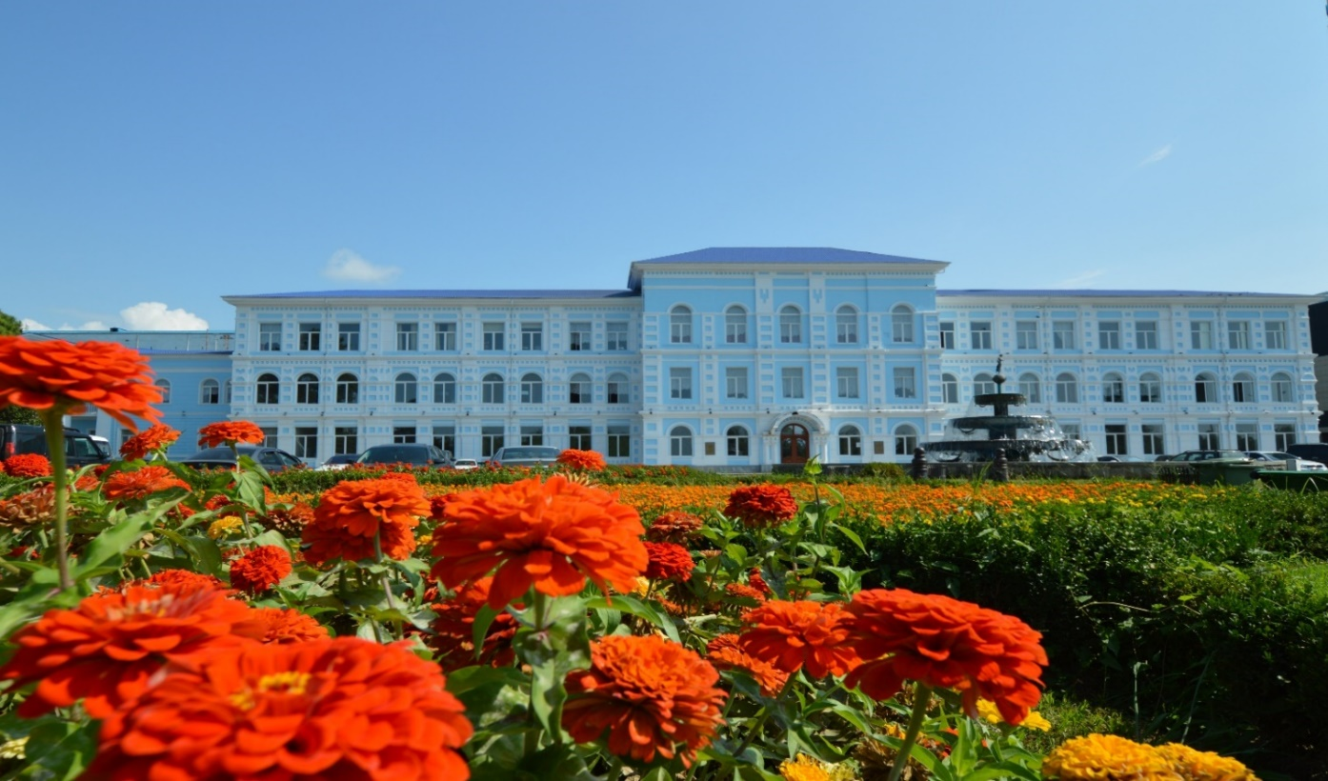

**Department of Strategic Development and**

**International Relations**

**09 - 13.06.2025**

**BATUMI**

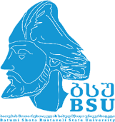-----------------------------------------------------------------------------------------------

**Monday, June 09th**

**1000** **MEETING POINT** – University main Building, Hall – Ninoshvili str. 35

**Group Photos**

**1030 – 1100** **REGISTRATION,** University main Building, Hall

**1100 – 1200** **WELCOME MEETING** (Room 32):

*Welcome address by the Rector, Prof. Tite Aroshidze*

*Welcome address by the Vice-Rector, Prof. Tamar Siradze*

*Welcome address by the Head of the Department of Strategic Development and International Relations, prof. M. Giorgadze*

*Presentation of Batumi Shota Rustaveli State University (Nunu Japaridze & Lela Tavartkiladze)*

**1200 – 1230 COFFEE BREAK**

**1230 – 1400 Self Presentation of the Partner Universities**

**1400 – 1500 LUNCH BREAK**

**1500 – 1600 Cultural visit: City guided tour**

**1800 – 2200 Welcome Dinner (Restaurant “Adjarian Wine House”)**



**Tuesday, June 10th**

**1000 – 1030 BSU TOUR: Visiting of the Faculty of Social Sciences and Law**

**1030 – 1100 BSU TOUR: Visiting of the Faculty of Economics and Business**

**1100 – 1130 COFFEE BREAK, Meeting with the Faculties members**

**1130 – 1200 BSU TOUR: Visiting of the Faculty of Natural sciences and Healthcare**

**1200 – 1230 BSU TOUR: Visiting of the Faculty of Exact Science and Education**

**1230 – 1300** **BSU TOUR: Visiting of the Faculty of Tourism**

**1300 – 1330 BSU TOUR: Visiting of the Faculty of Humanities and University Library**

**1330 – 1500 LUNCH BREAK**

**1500 – 1800** **Cultural visit: Gonio-Apsaros Fortress – 1st Century (Roman fortification-archaeological-architectural museum-reserve)**

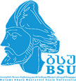…………………………………………………………………………………………………………

**Wednesday, June 11th**

**1000 – 1200** **Erasmus Mundus: Double Degrees - Good Practices**

**1200 – 1230 COFFEE BREAK, Meet the Faculties members**

**1230 – 1430 Erasmus Mundus: Double Degrees - Good Practices**

**1400 – 1600 LUNCH BREAK**

**1600 – 1800  Cultural visit: Ethnographic Museum “Borjgalo”**

**Thursday, June 12th**

**1000 – 1300 Internationalization of Higher Education – Expanding institutional strategies and global partnerships.**

**1200 – 1230 COFFEE BREAK, Meet the Faculties members**

**1300 – 1500 LUNCH BREAK**

**1500 – 1800** **Cultural visit: Excursion to Batumi Botanical Garden**

…………………………………………………………………………………………………………

**Friday, May 13th**

**1000 – 1200 Closing ceremony: Award of the Certificates to participants;**

**Group Photos**

**1200 – 1400 LUNCH BREAK**

**1400 – 1700****Free Time**