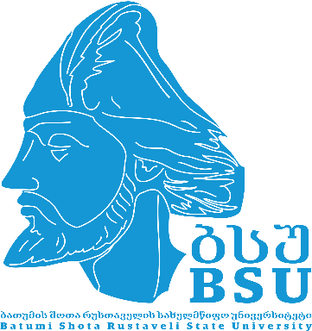

Batumi Shota Rustaveli State University
VI International Staff Week
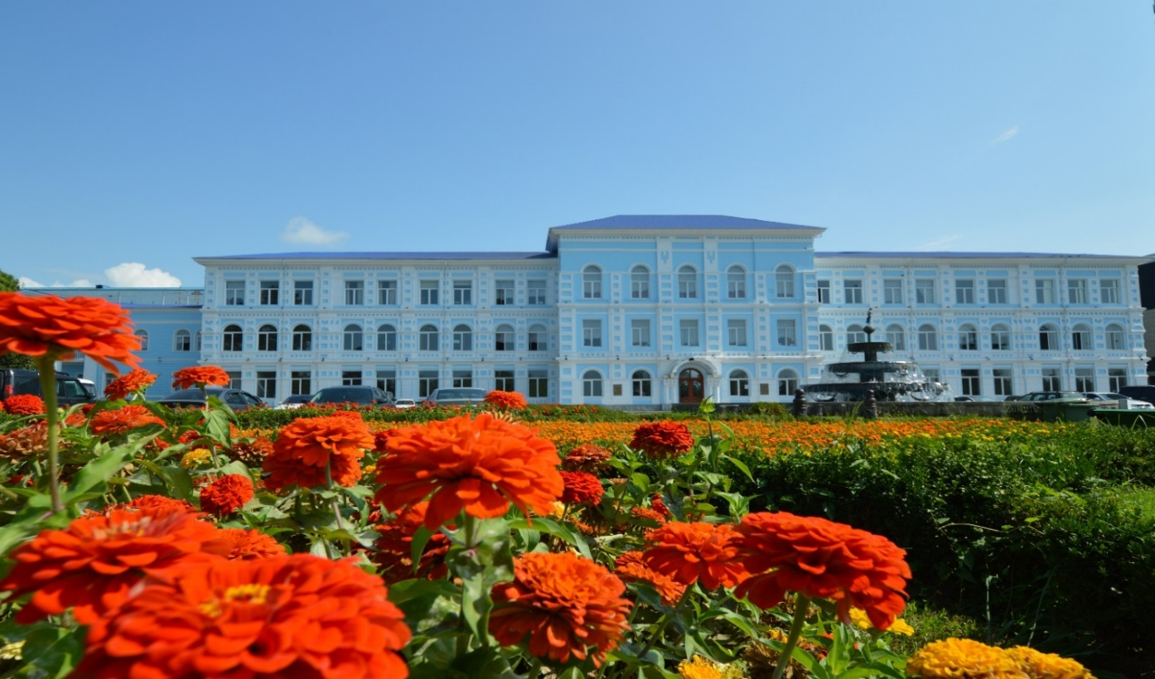

Department of Strategic Development and
International Relations

09 - 13.06.2025
BATUMI

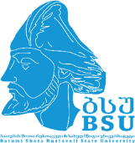-----------------------------------------------------------------------------------------------

Monday, June 09th
10⁰⁰ MEETING POINT – University main Building, Hall – Ninoshvili str. 35
Group Photos
10³⁰ – 11⁰⁰ REGISTRATION, University main Building, Hall
11⁰⁰ – 12⁰⁰ WELCOME MEETING (Room 32):
Welcome address by the Rector, Prof. Tite Aroshidze
Welcome address by the Vice-Rector, Prof. Tamar Siradze
Welcome address by the Head of the Department of Strategic Development and International Relations, prof. M. Giorgadze
Presentation of Batumi Shota Rustaveli State University (Nunu Japaridze & Lela Tavartkiladze)
12⁰⁰ – 12³⁰ COFFEE BREAK
12³⁰ – 14⁰⁰ Self Presentation of the Partner Universities
14⁰⁰ – 15⁰⁰ LUNCH BREAK
15⁰⁰ – 16⁰⁰ Cultural visit: City guided tour
18⁰⁰ – 22⁰⁰ Welcome Dinner (Restaurant “Adjarian Wine House”)

Tuesday, June 10th

10⁰⁰ – 10³⁰ BSU TOUR: Visiting of the Faculty of Social Sciences and Law

10³⁰ – 11⁰⁰ BSU TOUR: Visiting of the Faculty of Economics and Business

11⁰⁰ – 11³⁰ COFFEE BREAK, Meeting with the Faculties members

11³⁰ – 12⁰⁰ BSU TOUR: Visiting of the Faculty of Natural sciences and Healthcare

12⁰⁰ – 12³⁰ BSU TOUR: Visiting of the Faculty of Exact Science and Education

12³⁰ – 13⁰⁰ BSU TOUR: Visiting of the Faculty of Tourism

13⁰⁰ – 13³⁰ BSU TOUR: Visiting of the Faculty of Humanities and University Library
13³⁰ – 15⁰⁰ LUNCH BREAK
15⁰⁰ – 18⁰⁰ Cultural visit: Gonio-Apsaros Fortress – 1st Century (Roman fortification-archaeological-architectural museum-reserve)

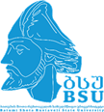…………………………………………………………………………………………………………

Wednesday, June 11th

10⁰⁰ – 12⁰⁰ Erasmus Mundus: Double Degrees - Good Practices
12⁰⁰ – 12³⁰ COFFEE BREAK, Meet the Faculties members
12³⁰ – 14³⁰ Erasmus Mundus: Double Degrees - Good Practices
14⁰⁰ – 16⁰⁰ LUNCH BREAK
16⁰⁰ – 18⁰⁰ Cultural visit: Ethnographic Museum “Borjgalo”

Thursday, June 12th

10⁰⁰ – 13⁰⁰ Internationalization of Higher Education – Expanding institutional strategies and global partnerships.
12⁰⁰ – 12³⁰ COFFEE BREAK, Meet the Faculties members
13⁰⁰ – 15⁰⁰ LUNCH BREAK
15⁰⁰ – 18⁰⁰ Cultural visit: Excursion to Batumi Botanical Garden

…………………………………………………………………………………………………………

Friday, May 13th
10⁰⁰ – 12⁰⁰ Closing ceremony: Award of the Certificates to participants;
Group Photos
12⁰⁰ – 14⁰⁰ LUNCH BREAK
14⁰⁰ – 17⁰⁰ Free Time

